

WEEK 5 - 2015
Score ( x / 24 ) | %

LAKELAND SHS MATHEMATICS

MATHEMATICS METHODS
test 1 – Part a

NAME: ______________________________ Time allowed: 25 min

NON-CALCULATOR SECTION

1. Using the unit circle supplied [4 marks]
(a)
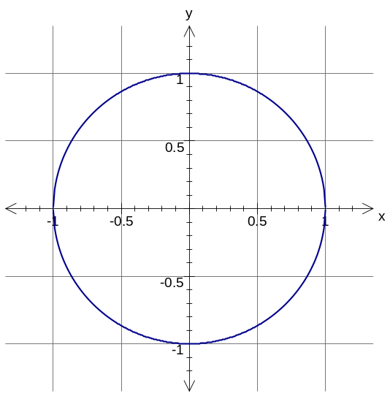
(i) find sin θ

sin θ = ____________

ii) draw the other angle with the same value as (i)
θ
(b)
(i) find cos θ

cos θ = ____________

ii) draw the other angle with the same value as (i)

α

2. Find the area of the triangle leaving your answer as an exact value. [2 marks]

4 cm
7 cm
60°

3. [5 marks]

- Convert these angles into degrees:

(i) 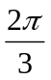

(ii) 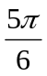

- Express these angles in radians

- 30º

- 210º

- State the exact value of sin (2π)

4. If f(x) = -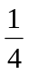x + 2 and g(x) = - 4x + 6 find: [5 marks]

a) f(4)

b) g(b + 2)

c) a if f(a) = 6

5. Find the midpoint of the line joining the points (–2, –4) and (3, –3) [2 marks]
6. The midpoint of the points P and (–2, –3) is (3, 7). Find P. [3 marks]

7. Identify the correct graph of the function 4x + 3y – 12 = 0 [3 marks]

A | 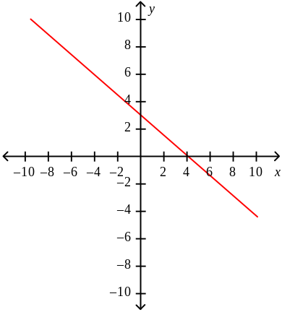 | D | 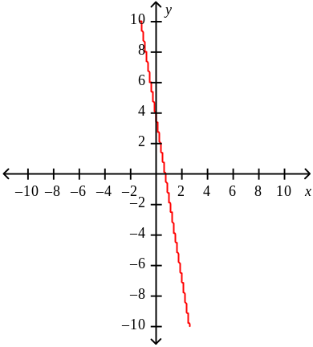
B | 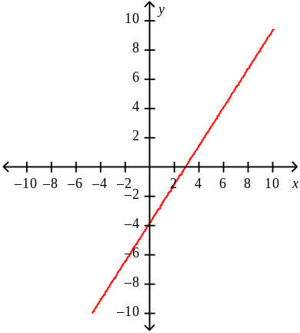 | E | 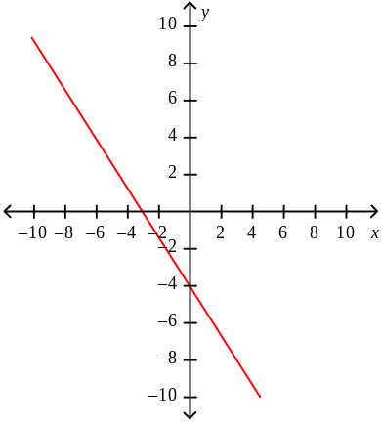
C | 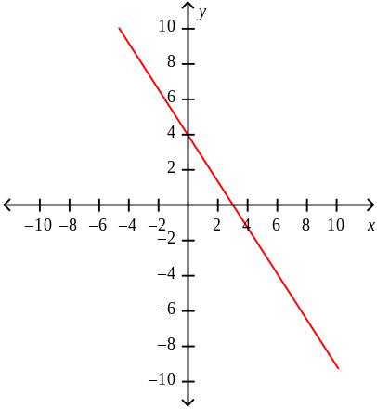
end of paRT A

WEEK 5 - 2015
Score ( x / 53 ) | %

LAKELAND SHS MATHEMATICS

MATHEMATICS METHODS
test 1 – Part B

NAME: ______________________________ Time allowed: 55 min

CALCULATOR AND NOTES ALLOWED

- [3 marks]
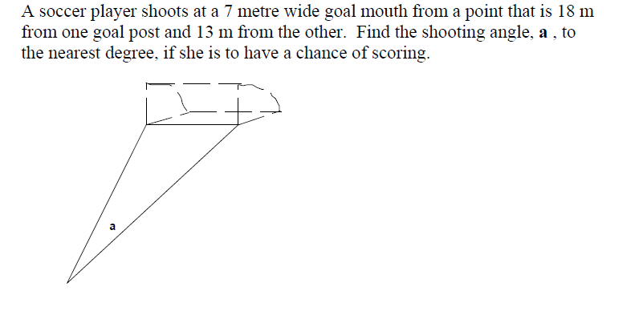

2. Find the value(s) of x in each of the following, giving your answer to 2 decimal places where appropriate. [3, 3 = 6 marks]
(a)
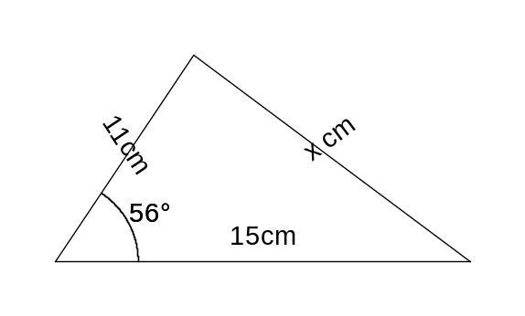

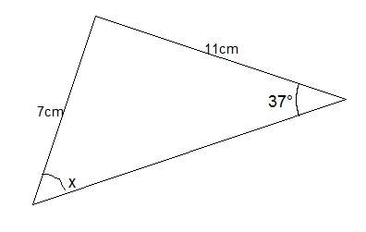
(b)

3. Determine the length of the side marked x for the triangle shown below. [5 marks]
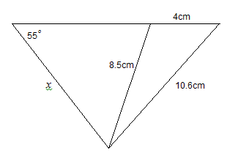

4. [2 marks]

A minor arc of length 5.8cm is formed by an angle of 2.5 radians at the centre of the circle. Calculate the radius of this circle correct to 1 decimal place.

5. [3 marks]
Find the area of the shaded shape below if the radius of the circle is 15 cm and angle a is 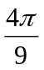radians. Round your answer to one decimal place.
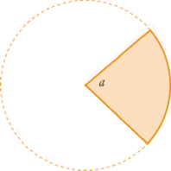

6. Find the area of the coloured shape below if the radius of the circle is 10 cm and angle θ is  radians. Give your answer in exact form. [3 marks]
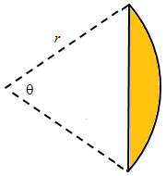

7. A clock has an hour hand that is 24cm long and a minute hand 38cm long.

Calculate the distance travelled by EACH hand in 45 minutes. [6 marks]

(a) Minute Hand = ____________

(b) Hour hand = ______________

8. [4 marks]
What is the equation of the line that passes through the points (-1, -1) and (7, -7)?

9. [4 marks]
What is the equation of the line parallel to the line y = 2x – 7, and going through the point (3, 0)?

10. [4 marks]
What is the equation of the line perpendicular to the line y = -4x + 4 that goes through the point (5, 3)?

11. [4 marks]
Find the angle that the line 3x + 4y + 3 = 0 makes with the (positive) x-axis.

12. [6 marks]

State the domain and range for the following functions:
a) 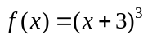 | b) | 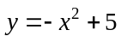
Domain: _________________________________ |  | Domain: _________________________________
Range: __________________________________ |  | Range: __________________________________
c) 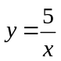
Domain: _________________________________

Range: __________________________________

13. [7 marks]
A segmental arch used in architecture has the following shape as seen in the diagram on the right. The curve of the arch is a circular arc with its centre being the intersection of the diagonals of the window. If the rectangular window measures 900mm wide and 1200mm high, calculate:
- 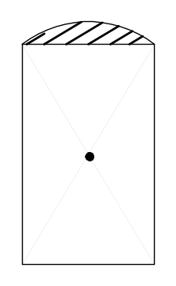the radius of the arch

- the area of the arch

